**CHATBOT USING NLTK**

**Introduction**

**Objective**:

To create a basic chatbot that can answer predefined questions about robotics using NLTK for text processing.

**Problem Statement**:

There is a need for a simple conversational AI that can handle FAQs efficiently in a specific domain.

### ****Tools and Technologies****

* + **Programming Language**: Python
  + **Library**: NLTK (Natural Language Toolkit)
  + **Other Tools**: Knowledge base (hardcoded dictionary), basic NLP preprocessing (tokenization, stopword removal, stemming).

**Explanation**

This Python code implements a simple chatbot focused on answering questions about robotics. It pre-processes user input by tokenizing, removing stop words, and stemming, then compares the processed input with predefined questions in a knowledge base. If a match is found, the chatbot provides the corresponding answer; otherwise, it apologizes for not having an answer.

### ****Results****

* + Correctly identifies questions it is trained on.
  + Returns a default response for unknown questions.

**PROJECT CODE:**

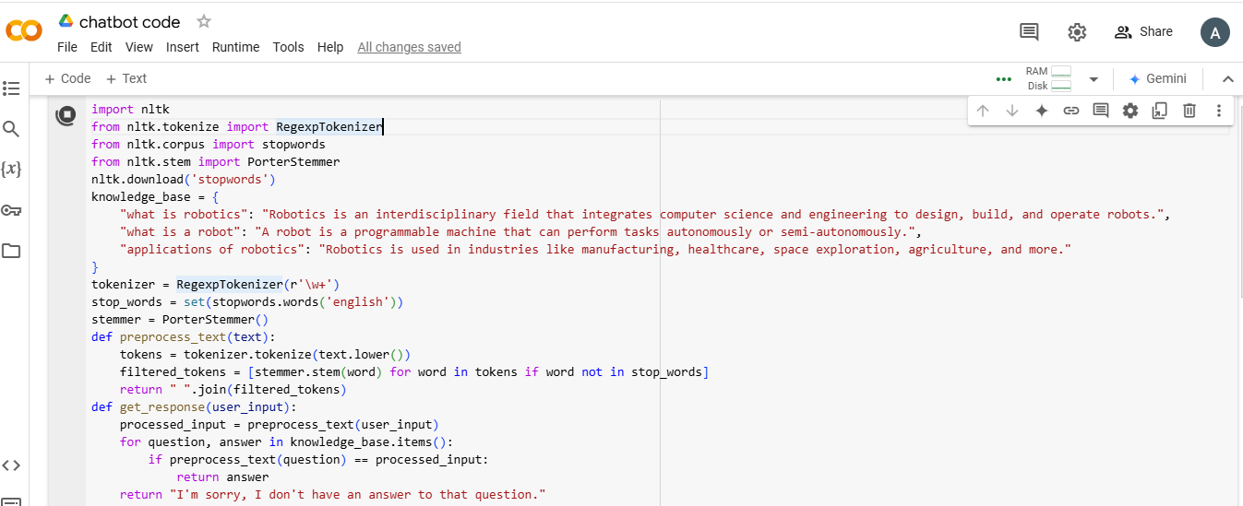

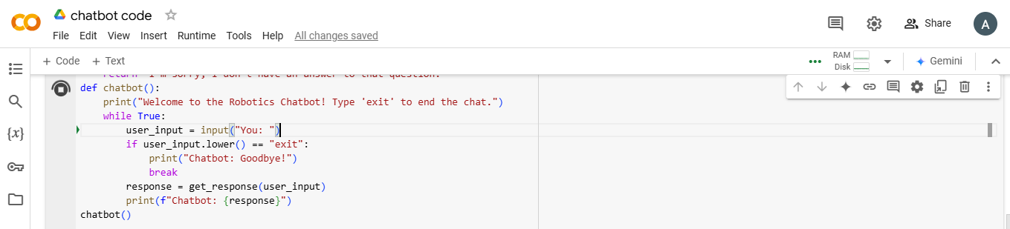

**OUTPUT:**

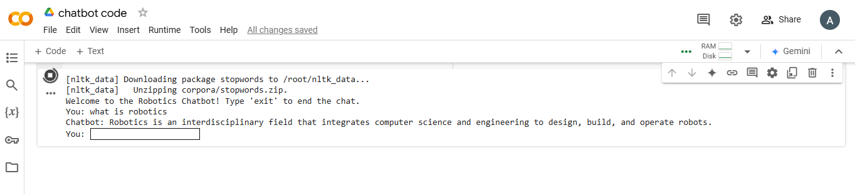

**C0DE:**

import nltk

from nltk.tokenize import RegexpTokenizer

from nltk.corpus import stopwords

from nltk.stem import PorterStemmer

nltk.download('stopwords')

knowledge_base = {

    "what is robotics": "Robotics is an interdisciplinary field that integrates computer science and engineering to design, build, and operate robots.",

    "what is a robot": "A robot is a programmable machine that can perform tasks autonomously or semi-autonomously.",

    "applications of robotics": "Robotics is used in industries like manufacturing, healthcare, space exploration, agriculture, and more."

}

tokenizer = RegexpTokenizer(r'\w+')

stop_words = set(stopwords.words('english'))

stemmer = PorterStemmer()

def preprocess_text(text):

    tokens = tokenizer.tokenize(text.lower())

    filtered_tokens = [stemmer.stem(word) for word in tokens if word not in stop_words]

    return " ".join(filtered_tokens)

def get_response(user_input):

    processed_input = preprocess_text(user_input)

    for question, answer in knowledge_base.items():

        if preprocess_text(question) == processed_input:

            return answer

    return "I'm sorry, I don't have an answer to that question."

def chatbot():

    print("Welcome to the Robotics Chatbot! Type 'exit' to end the chat.")

    while True:

        user_input = input("You: ")

        if user_input.lower() == "exit":

            print("Chatbot: Goodbye!")

            break

        response = get_response(user_input)

        print(f"Chatbot: {response}")

chatbot()

**OUTPUT:**

[nltk_data] Downloading package stopwords to /root/nltk_data...

[nltk_data] Unzipping corpora/stopwords.zip.

Welcome to the Robotics Chatbot! Type 'exit' to end the chat.

You: what is robotics

Chatbot: Robotics is an interdisciplinary field that integrates computer science and engineering to design, build, and operate robots.

You: 